By: Rebecca Cate

Code through Git/Hub link

<https://github.com/RCate>

HW_Wk_4

**District Summary:**



**School summary**

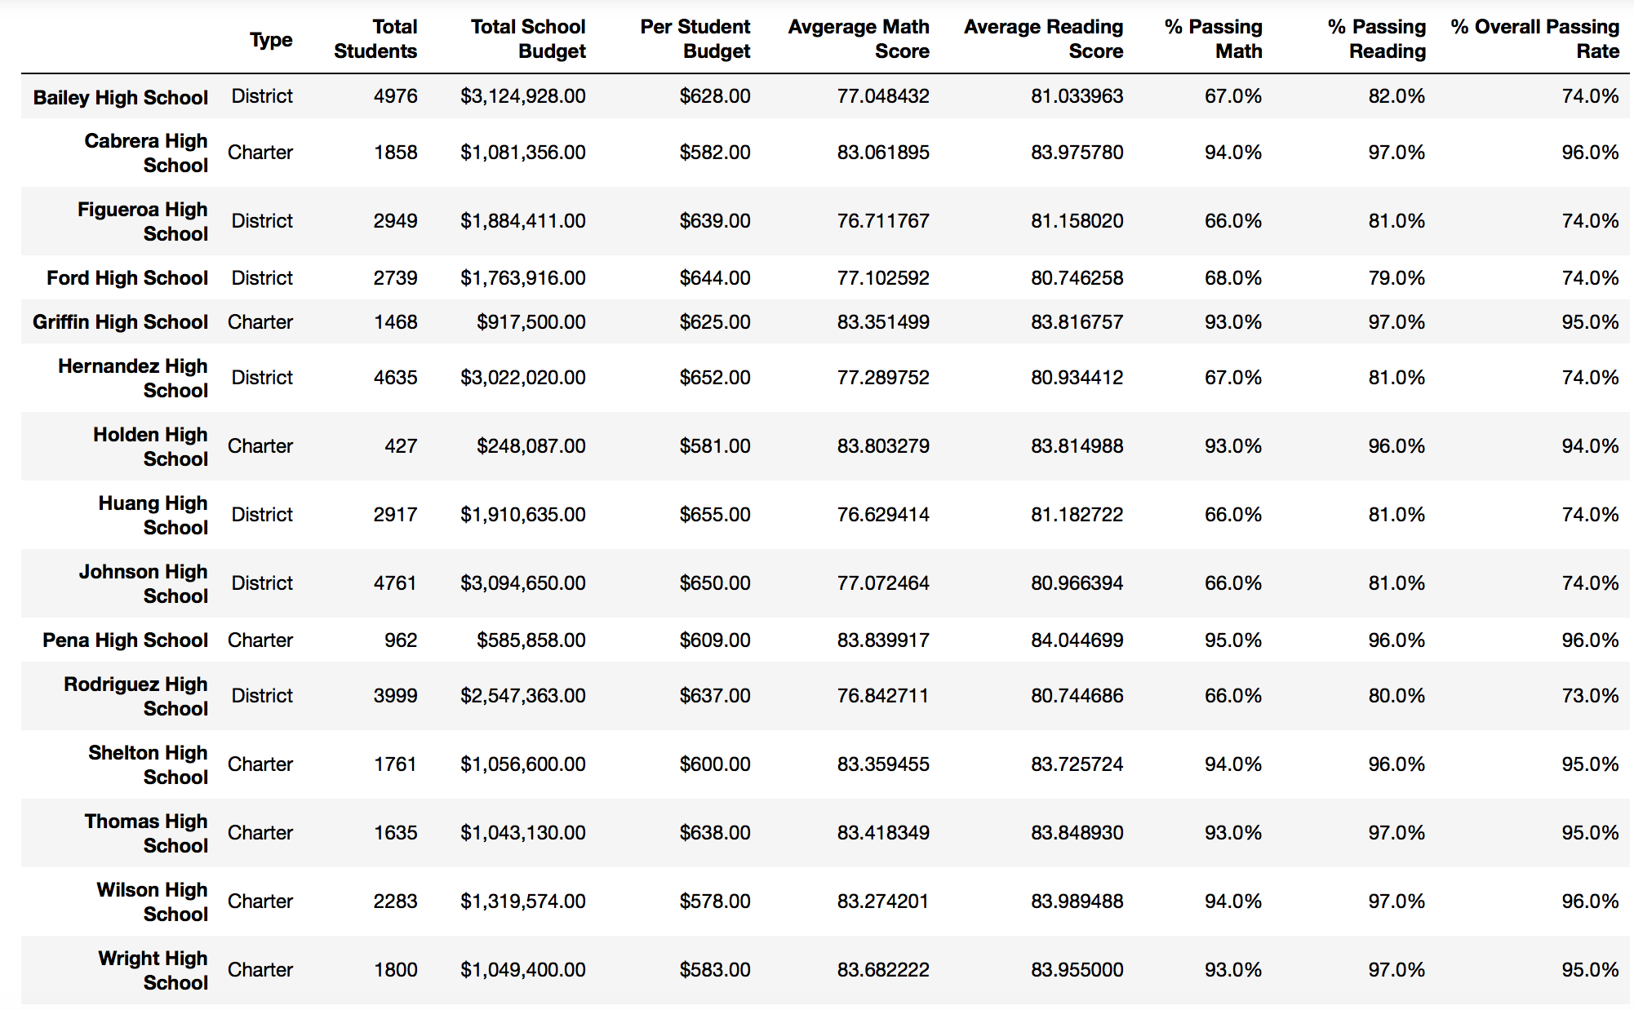

**Greatest by % Overall Passing**

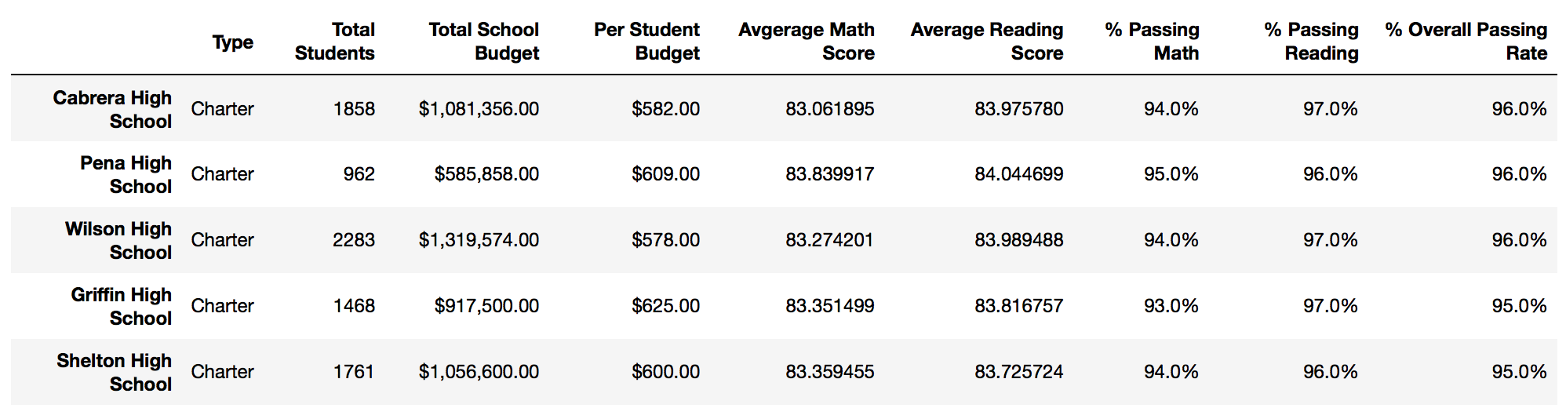

**Lowest by %Overall Passing**

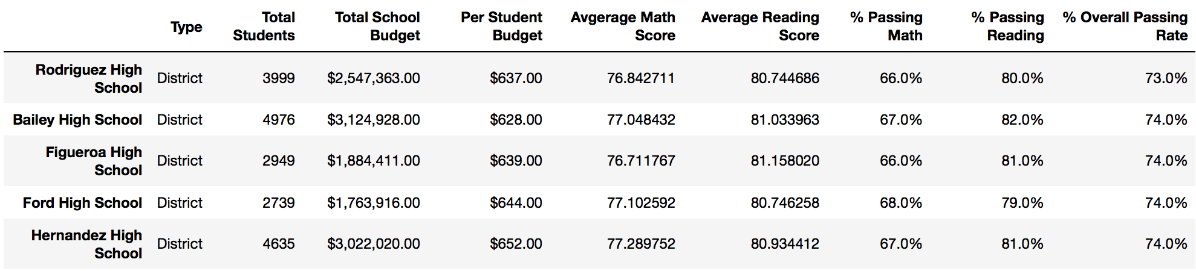

**Math Scores by grade:**

Doesn’t show too much… there’s a variation around 1% for most grades… but the schools seem to be pretty consistent across the grades…

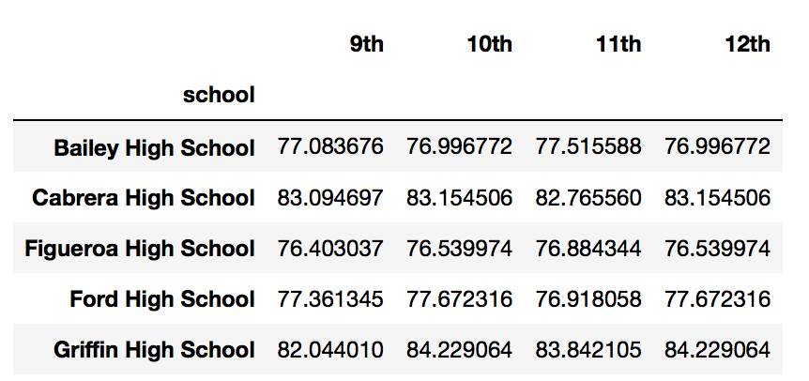

**Reading Scores by grade**

Same as Math scores…

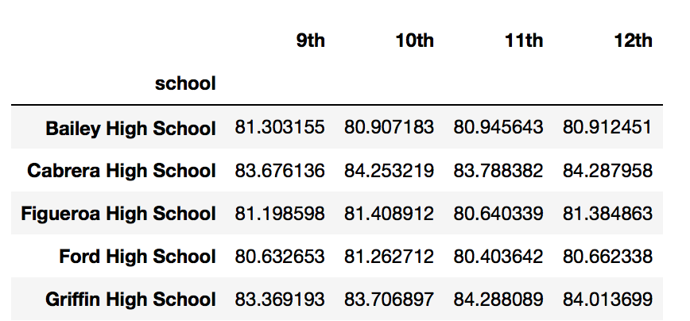

**By Spending per student**

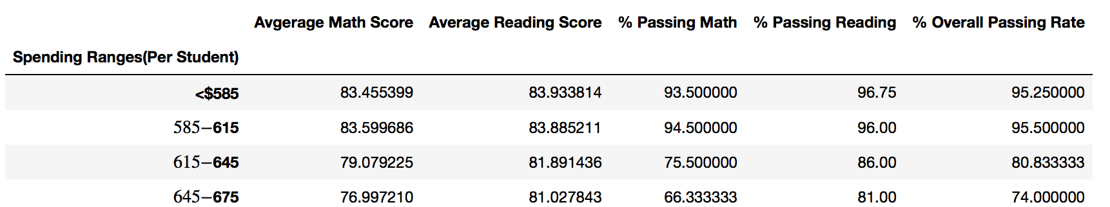

**By school size:**

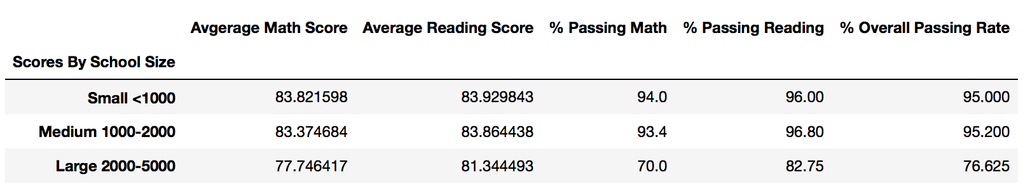

**Schools by Type:**

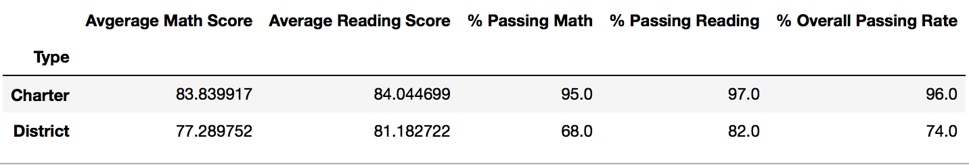

**School Summary - by Rebecca Cate**

Upon reviewing the data presented for the school district and the schools - it became clear that Charter schools were a clear indicator of success based upon percentages for Math, Reading and Overall passing rates - according to the data given.

The various comparisons that were completed were comparing the top 5 schools for greatest and lowest passing rate for Math and Reading, comparing scores based off of size and $/student ratio, math and reading scores by grade and then finally looking at the 2 different types of schools within the district, Charter and Traditional Style (District).

The Charter schools rose to the top in almost every comparison - they had higher scores, higher passing rate and still had a lower $/student ratio. It is clear - the district’s overall #’s benefits from having charter schools in them. The question remains to be answered if the students are clearly benefiting.

Some may argue that because all the #’s point to Charter schools rising above the majority of the high schools that they are superior - but are there are other factors to be considered. A few factors to consider are sports, and (the polar opposite) low income families in the larger schools. Also, the fact the charter schools have a lower $/student ratio is even more impressive because Charter schools are generally not given funding for buildings.

There are factors that are not being pulled from the data listed - such as the % of students on free/reduced lunch, # of students with disciplinary issues and how those issues are resolved - which do affect overall scores for that demographic of student.

The data presented clearly shows Charter schools produce better academic results - that is the story that this data is telling. Yet, there have been arguments made for the fact that there are other factors to consider - and that data isn’t included in this project for that complete story.